1)Github repo URL:
https://github.com/Rishabh-kumar45/github-skills-challenge

2)Pull request URL:
https://github.com/Rishabh-kumar45/github-skills-challenge/pull/1
3) Screenshot showing the GitHub Actions workflows:
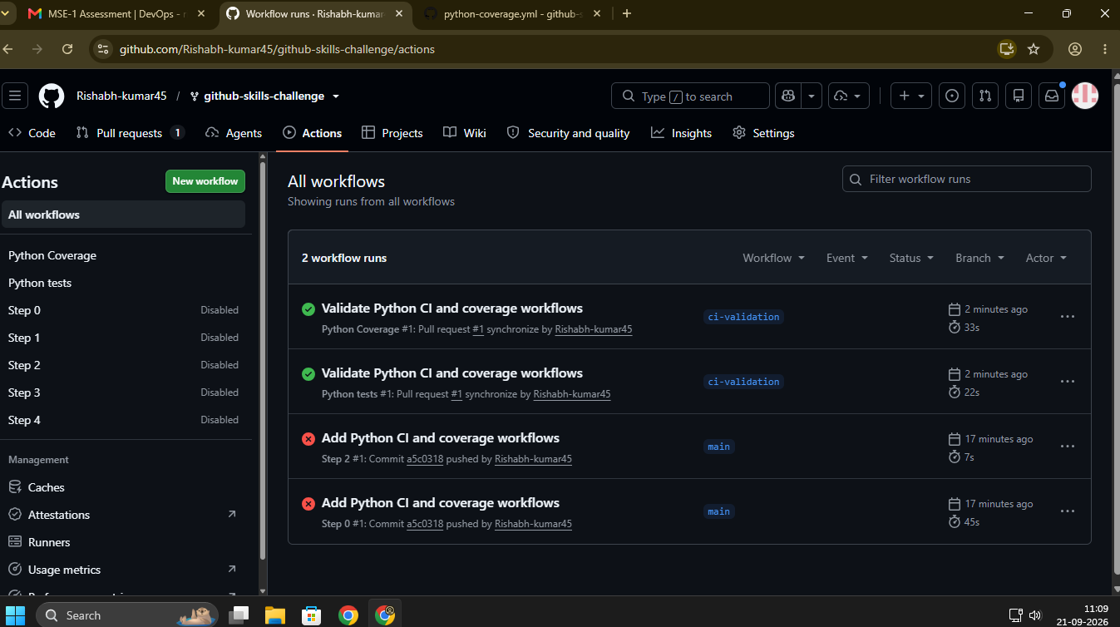

4) Screenshot showing a successful test workflow execution:
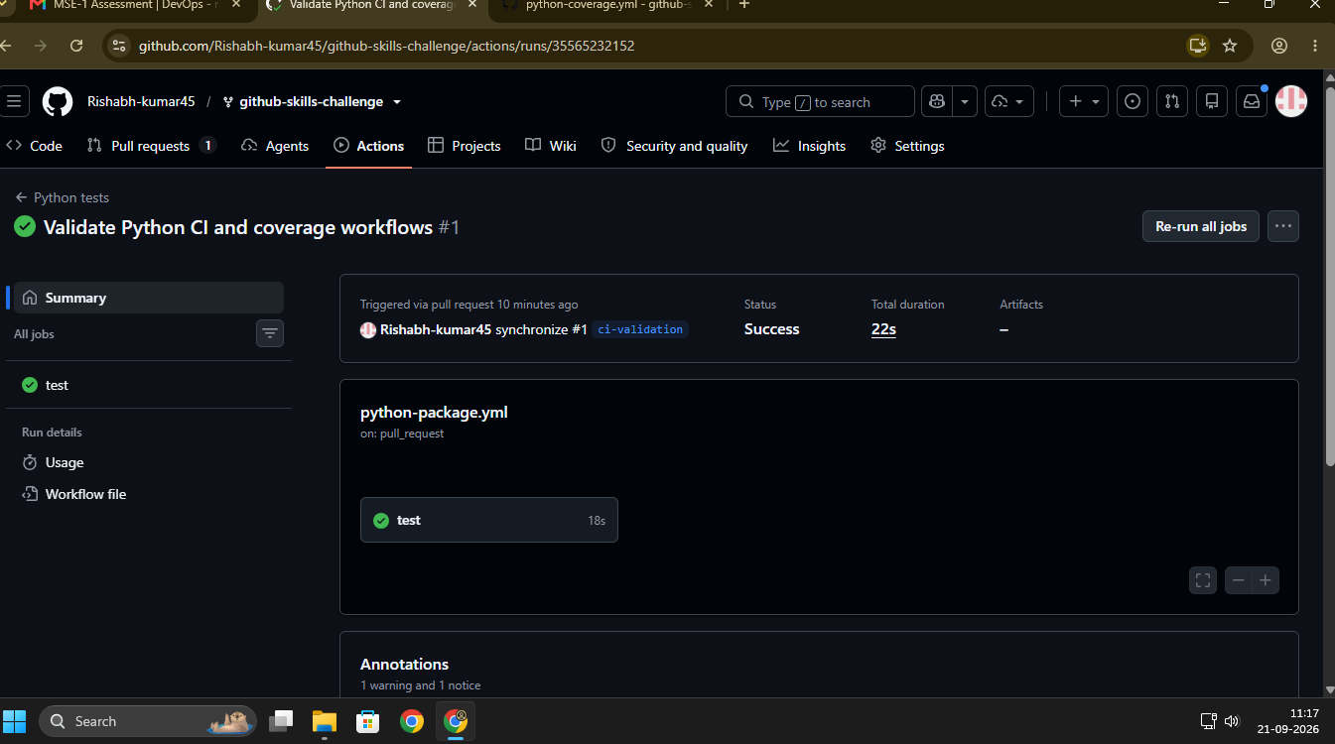

5) Screenshot showing the coverage result/comment on the pull request:
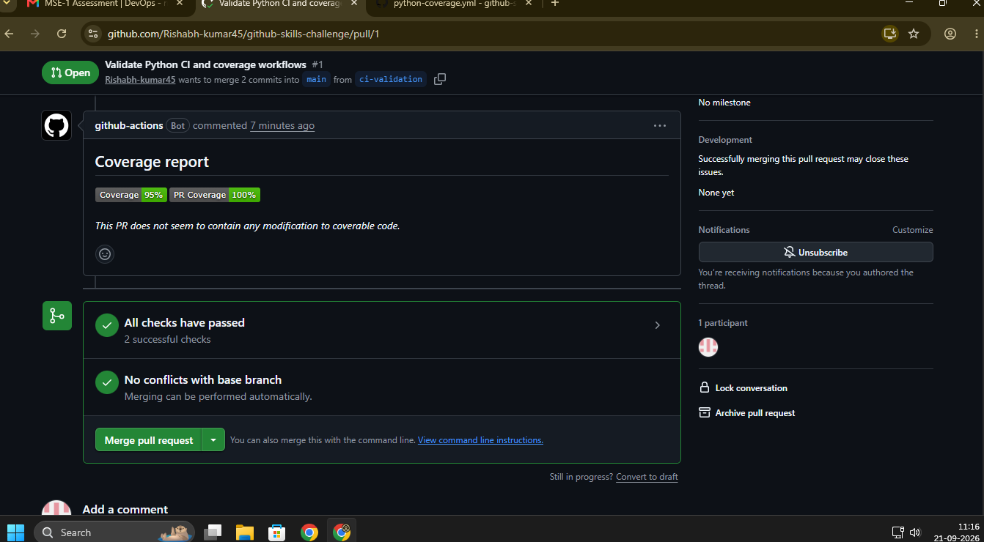
6) Screenshot showing the final repository/workflow files:
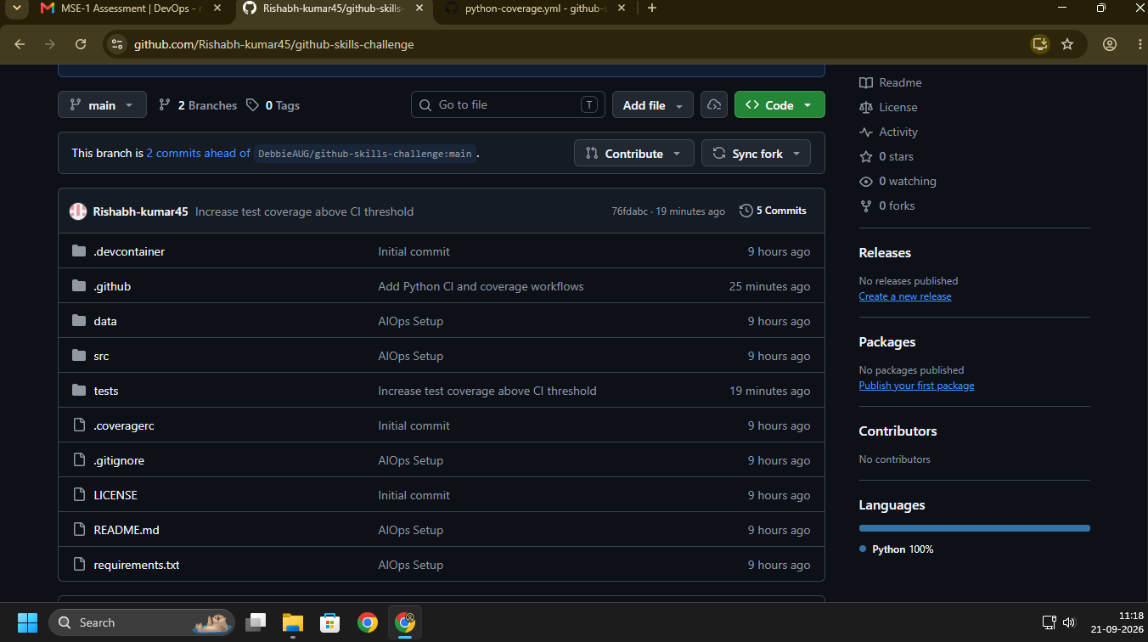
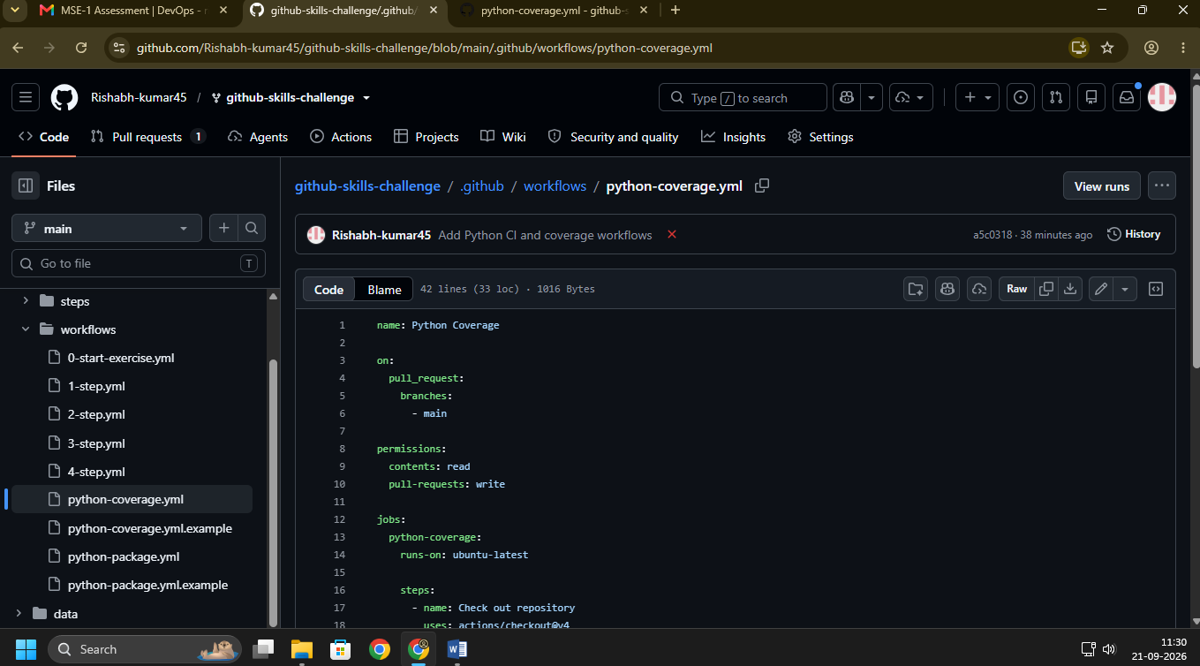

Test Passed:
